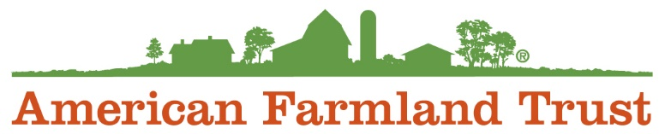

Climate Policy and Research Intern

About AFT
American Farmland Trust is the only national organization that takes a holistic approach to agriculture, focusing on the land itself, the agricultural practices used on that land, and the farmers and ranchers who do the work. Since our founding in 1980, AFT has helped permanently protect over 6.5 million acres of agricultural lands, advanced environmentally-sound farming practices on millions of additional acres and helped thousands of farm families make a go of it (primarily through programs that increase farm viability and/or enhance farmland access). Long a pioneering leader, AFT is now riding a new wave of growth, driven by agriculture’s most pressing needs and opportunities.

We believe diversity drives innovation. We are inclusive. We embrace differences. We recognize and respect the fundamental value and dignity of all our employees. We celebrate the unique traditions, heritages, and experiences our employees bring to the workplace. We are committed to creating and sustaining an inclusive culture that promotes and values diversity, and where everyone feels empowered to bring their authentic selves to work every day.

We provide equal employment opportunities (EEO) to all employees and applicants for employment without regard to race, color, religion, sex, sexual orientation, expression or identity, national origin, age, disability, or genetics. In addition to federal law requirements, American Farmland Trust complies with applicable state and local laws governing nondiscrimination in employment in every location in which we have facilities. This policy applies to all terms and conditions of employment, including recruiting, hiring, placement, promotion, termination, layoff, recall, transfer, leaves of absence, compensation, and training.

Reporting to the Climate Policy Manager, the Graduate Climate Policy Intern will work closely with the Climate Policy Manager and with other members of the AFT policy and research teams during the summer of 2022 to do research and support development of an organization-wide climate policy strategy to achieve net-zero emissions from the agricultural sector by 2050. Tasks for this position will include compiling state-level data to model benefits of different practice adoption levels, and topic-specific research to determine what is needed to reach net-zero emissions in the agriculture sector nationwide by 2050 and to identify state and federal policy pathways related to carbon markets, methane and nitrous oxide emissions reductions, carbon sequestration, practice adoption, policy pathways, political feasibility, and more.

What You’ll be Working On

- Research (literature reviews), compiling and organizing data, policy ideation, collaboration with research and policy staff, and other duties as identified by the supervisor.

Requirements

- Graduate level coursework in field of climate, policy, agriculture, conservation, and/or environmental science.

Why you should apply

- Be a part of a purpose-driven, committed, knowledgeable, high-performing, experienced and fun team
- Learn and become passionate about food systems and agriculture policy in New England
- A diverse and inclusive work environment
- A cause and mission you can be proud of
- Remote work opportunities
- Flexible scheduling

