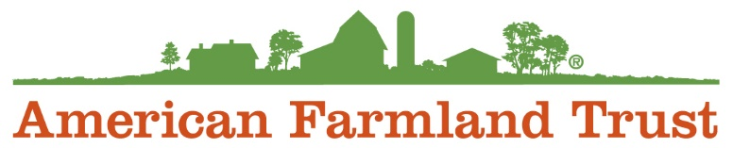

Communications & Membership Intern

About AFT
American Farmland Trust is the only national organization that takes a holistic approach to agriculture, focusing on the land itself, the agricultural practices used on that land, and the farmers and ranchers who do the work. Since our founding in 1980, AFT has helped permanently protect over 6.5 million acres of agricultural lands, advanced environmentally-sound farming practices on millions of additional acres and helped thousands of farm families make a go of it (primarily through programs that increase farm viability and/or enhance farmland access). Long a pioneering leader, AFT is now riding a new wave of growth, driven by agriculture’s most pressing needs and opportunities.

We believe diversity drives innovation. We are inclusive. We embrace differences. We recognize and respect the fundamental value and dignity of all our employees. We celebrate the unique traditions, heritages, and experiences our employees bring to the workplace. We are committed to creating and sustaining an inclusive culture that promotes and values diversity, and where everyone feels empowered to bring their authentic selves to work every day.

We provide equal employment opportunities (EEO) to all employees and applicants for employment without regard to race, color, religion, sex, sexual orientation, expression or identity, national origin, age, disability, or genetics. In addition to federal law requirements, American Farmland Trust complies with applicable state and local laws governing nondiscrimination in employment in every location in which we have facilities. This policy applies to all terms and conditions of employment, including recruiting, hiring, placement, promotion, termination, layoff, recall, transfer, leaves of absence, compensation, and training.
The Midwest Communications and Membership Intern supports communications and program outreach to implement the mission and vision of American Farmland Trust in the Midwest. This position coordinates communications activities to build AFT’s visibility throughout the Midwest region, ensuring that Midwest communications is consistent and embedded within AFT’s national communications strategies.
In this paid internship, you will assist the Midwest Communications and Outreach Manager to 1) help build and deepen our digital presence, 2) help create communications strategies, and 3) develop engaging programmatic success stories.
At this time, this position is completely remote. This year long, part-time internship will begin on June 6th, 2022 and run for 12 months.

What You’ll be Working On

- In coordination with the Communications and Outreach Manager, develop and implement a social media strategy that will broaden AFT’s visibility and reach, and serve as a set of guidelines for future interns to build upon.
- Create, edit, and post social media content (Facebook) using tools like Canva and help develop a social media content calendar alongside Communications and Outreach Manager.
- Mine our social and web data to discover the post popular content and figure out how to repurpose it.
- Help test new ways for AFT to be more equitable and inclusive in our messaging and in how we put our messages out into the world.
- Help assist in creating 2 story profiles that expands our reach and deepens our audience’s affinity for our work in our Midwest programs like our target priority watersheds, solar, advancing conservation cropping systems, and/or carbon science.
- Edit print and electronic materials.
- Other opportunities as assigned to reach your professional goals and/or interests!

Requirements

- Interest in AFT’s mission and passion for conservation, agriculture, and storytelling
- College student or recent graduate
- Ability to work at least part-time or full-time
- Strong written and oral communications skills
- Basic knowledge of Microsoft Office, Adobe Suite, Canva, and other graphic design platforms
- Experience with the major social media platforms including Facebook, YouTube, Instagram, Twitter, Pinterest and Snapchat
- Basic knowledge of social media analytics software including Facebook Insights, Google Analytics and Twitter Analytics to track audience engagement and campaign performance

Why you should apply

- Be a part of a purpose-driven, committed, knowledgeable, high-performing, experienced and fun team
- Learn and become passionate about food systems and agriculture policy in New England
- A diverse and inclusive work environment
- A cause and mission you can be proud of
- Remote work opportunities
- Flexible scheduling

